https://www.ecosystemforkids.com/games/4th-grade/scientific-names-of-animals/activity.html
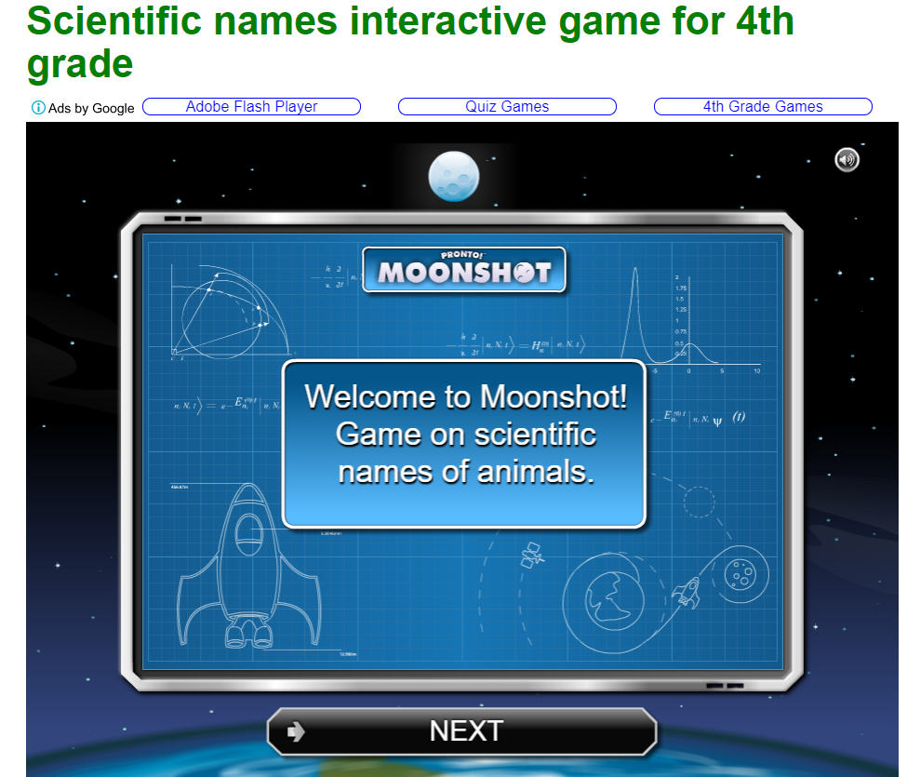

http://sciencenetlinks.com/interactives/class.html
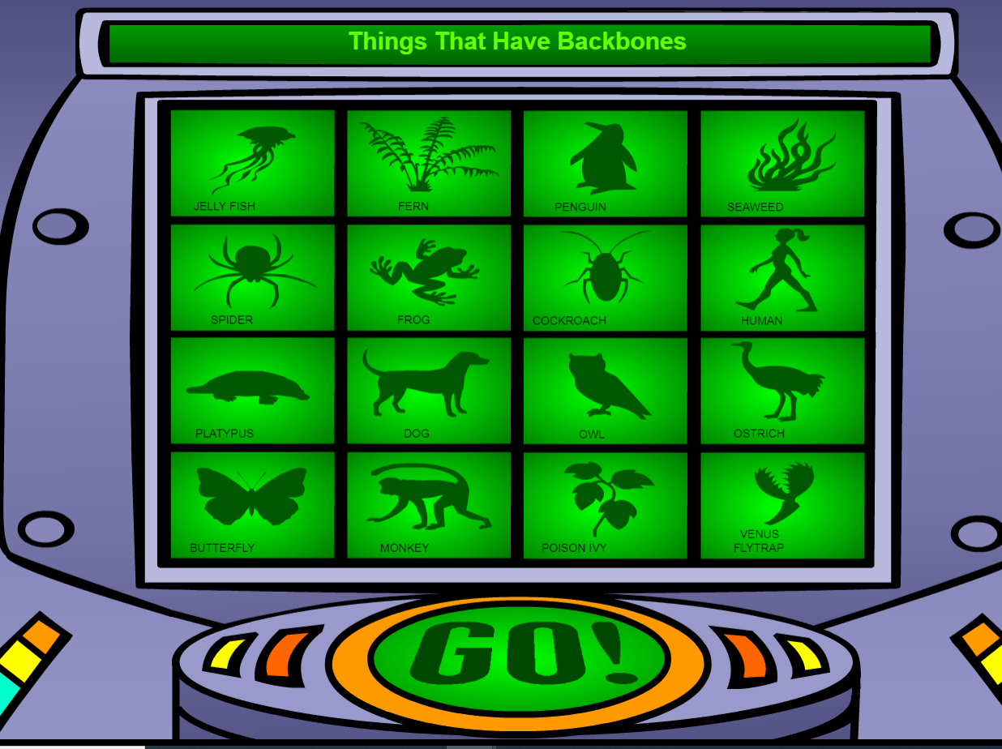

http://web.archive.org/web/20090201153752/http://hhmi.org/coolscience/forkids/critters/critter1.html


